**Components of Docker**

1. Dockerfile:

* A text file that contains a set of instructions for building a Docker image.
* Dockerfile specifies the base image, adds dependencies, copies files, and runs commands necessary to create the image.
* Example instructions include `FROM`, `RUN`, `COPY`, `EXPOSE`, `CMD`, etc.
* Dockerfiles allow for reproducible builds and version-controlled configurations.

2. Docker Image:

* A lightweight, standalone, and executable software package that contains everything needed to run a particular application: code, runtime, libraries, dependencies, and configuration files.
* Docker images are built from Dockerfiles and are stored in a layered format.
* Images are immutable and can be shared, distributed, and reused across different environments.
* Docker images can be stored locally or pushed to a Docker registry for sharing with others.

3. Docker Container:

* An instance of a Docker image that runs as a process on the host machine's operating system.
* Containers are lightweight, portable, and isolated from each other and the host system.
* Containers encapsulate the application and its dependencies, ensuring consistency across different environments.
* Docker containers can be started, stopped, paused, and deleted using Docker commands.

4. Docker Registry (Docker Hub):

* A repository for storing and sharing Docker images.
* Docker Hub is the default public registry provided by Docker, where users can find official images for popular software packages.
* Users can also push their custom-built Docker images to Docker Hub for sharing with others.
* Docker registries allow users to organize, manage, and distribute Docker images across different teams and environments.
* Users can set up private Docker registries for storing proprietary or sensitive images within their organization.

Steps for creating a docker image and docker container.

* First we need an Instance with the Amazon Linux 2 AMI.

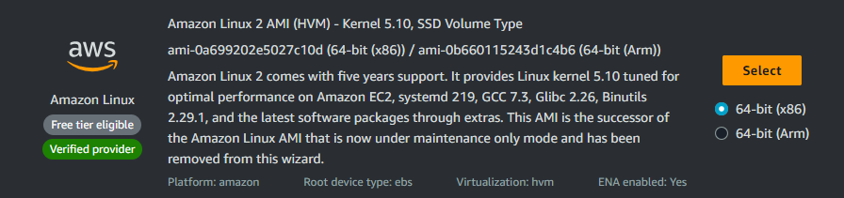

* After launching the Instance take the ssh of the instance.
* Now login as a root user.
* We need to install docker.
* Hit command “yum install docker -y”.
* Now we need to start and enable the service.
* Hit command “systemctl start docker”.
* Hit command “systemctl enable docker”.

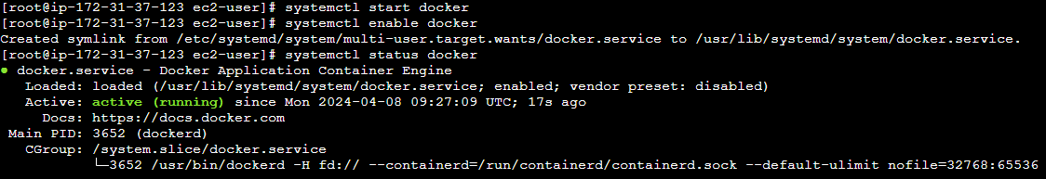

* Now we need a image to create a container.
* We will pull an image.
* Hit command “docker pull nginx”
* Hit command “docker images” to view all the images.

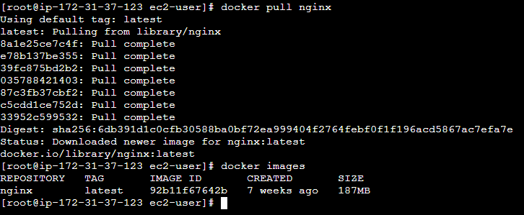

* Now we have to run the image to create a container.
* “docker run -d image_name” to run the image in background.
* Hit command “docker ps” to view the currently running container.

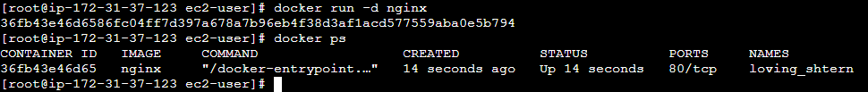

* Now we need to get access of the container.
* Hit command “docker run -it –name container_name image_name /bin/bash” to enter the container.

Docker Commands

* # docker images : to view all the images available.
* # docker ps : to view all the running containers.
* # docker ps -a : to view all the containers including running and stopped.
* # docker pull image_name : to pull the image.
* # docker rm container_name : to remove the container.
* # docker start container_name : to start the container.
* # docker rmi image_name : to remove the image.